**Install Pyhon**

Execute

Mark option Add Python 3.5 to PATH

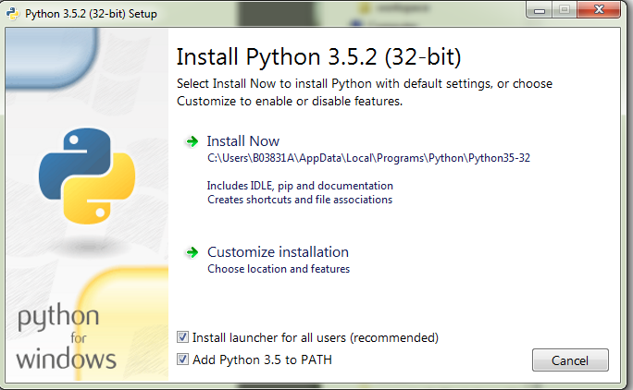

Customize instalatioin

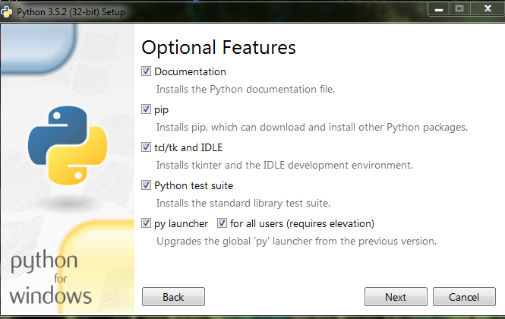

Next

Mark Install all Users

Modify path to C:\Python35-32

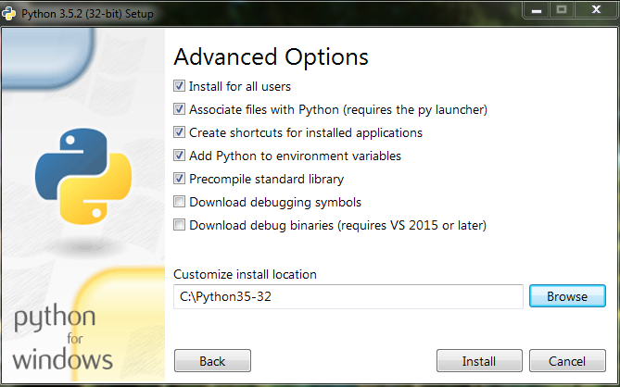

Install

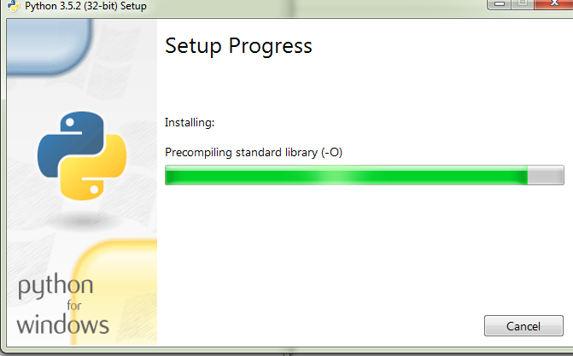

wait

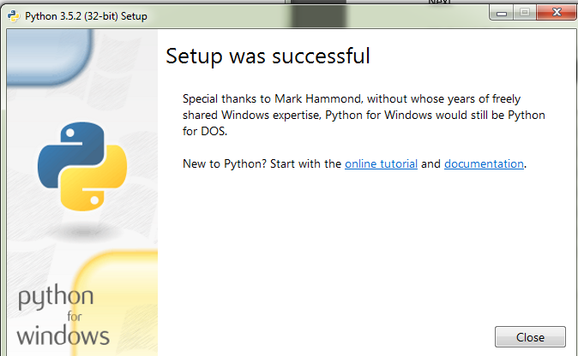

Close

Try to execute python on console:

Windows + R

Cmd

Enter

Python

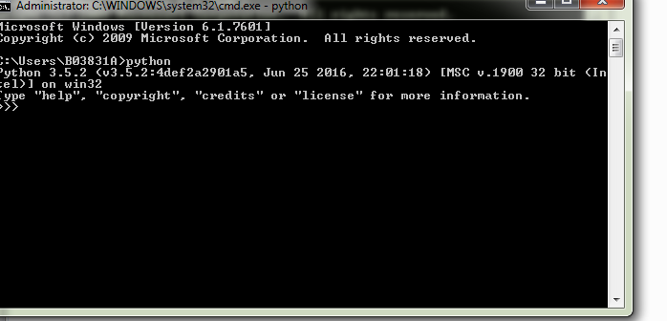

Exit()

**Install Robot Framework**

On Python

Pip install robotframework

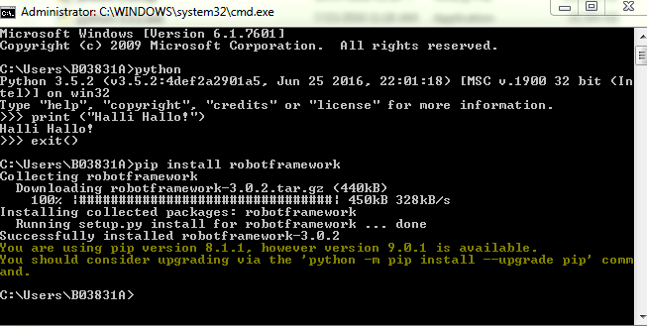

**Jenkins**

Dowonload fomr site:

https://jenkins.io/

Execute Jenkins.msi

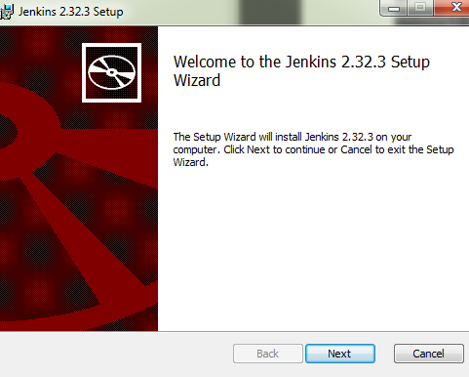

Next and modify path to: C:\Program Files (x86)

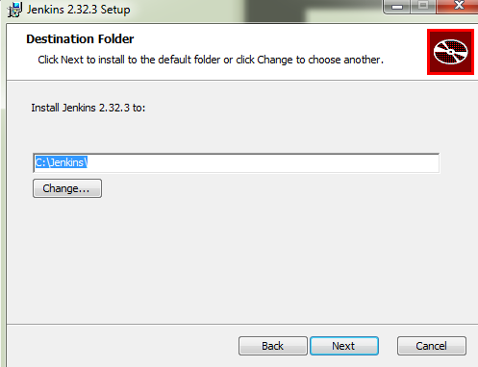

Next and Install

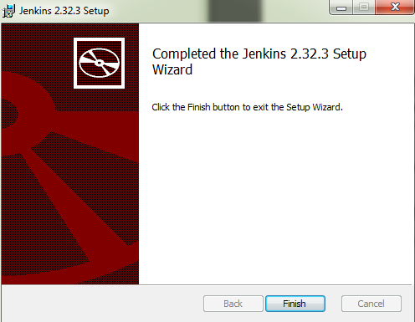

Finish (If end prematurely execute as admin)

Open browser and access to :

<http://localhost:8080/>

Then this will appear

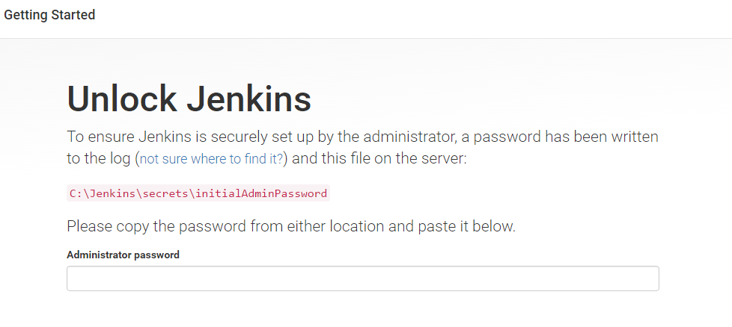

Copy and paste password from path

C:\Jenkins\secrets\initialAdminPassword

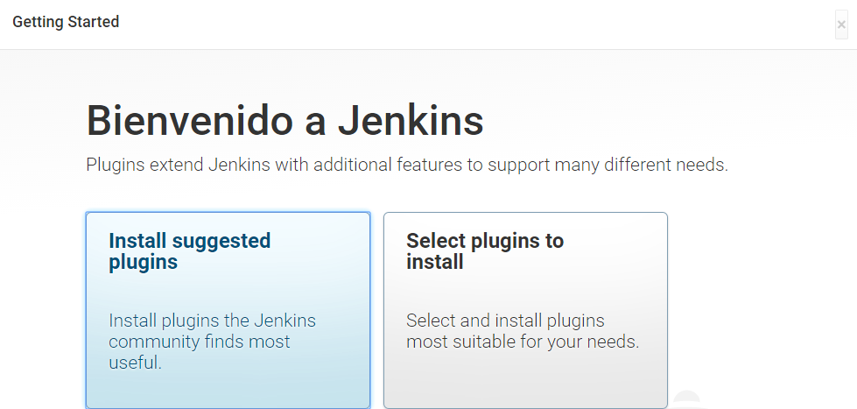

Here just select the top right corner X.

Then start

